Mpd testing resutls

John Reid S1511280

# Introduction

Once the testing was completed the results had to be looked at in order to determine how well the app followed each of Nielson’s 5 laws. This report will discuss the initial testing first and then the second round of testing that happened 2 days after the initial testing.

# First Set of Testing

## How easy was it to navigate the app when performing tasks?

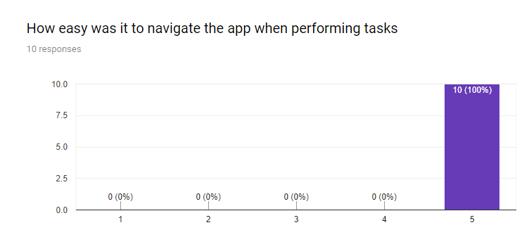

Before the test began it was expected that the learnability of this app was simple and that they would have no issues when learning the app. When the testing was conducted all of the participants stated that they found the app easy to use and that they had no issues. These results clearly show that the learnability of the app was simple and that they had no issues with the initial learning of the functions of the app.

## Were you able to easily identify what you could interact with

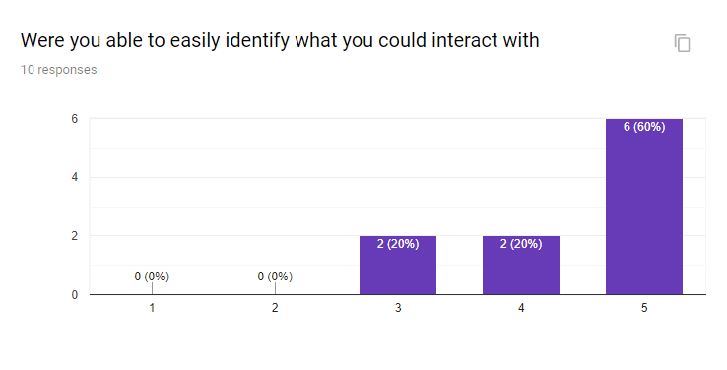

It was expected that the efficiency of the app would be a high one given its basic layout but the results did not reflect this expectation. 60% of the participants stated that they could easily identify what they could interact with the app without any issues. 20% of the participants rated 4 on this scale which means they could identify the majority of the functions in the app and 20% also marked 3 for this which means they had issues with understanding some of the identification with what they could interact with. When further clarification was asked for by the participants they all stated that they thought they could just click on the name of the earthquake and more information would appear. What they said coincides with the errors they made as each of these participants attempted to click on the card view to get more information and not the button. These results show that the application is mostly efficient but if it was changed so that you only had click on the card view of each earthquake to make the extra information appear then it would clear up any inefficiencies in the app.

## How satisfied were you with the app and how it performed?

## 

The expectation was that at least the majority of the users found it satisfying to use the application. 90% of the people who used the app said that they found it extremely satisfying to use which reinforces that the app fits in well with the satisfaction law. 10% selected that it was satisfying but not extremely satisfying upon asking for clarification it was stated that the participant didn’t like the colour scheme. It did not seem necessary to change the colour scheme as the majority of the participants enjoyed it and it did not impact the 10% so much that they hated the app.

## Would you use this app again if you needed to?

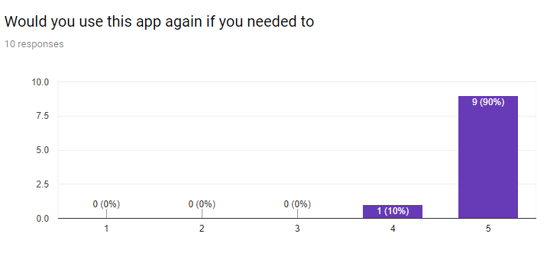

The expectation of this was that the participants would want to use the app again. 90% of the people said that they would use the app again without any issues and 10% said that they would most likely use it again so this further reinforces that the satisfaction law has been followed.

# Second Set of Testing

The second set of testing was performed 2 days after the first set of testing in order to test the memorability of the app. It was expected that it would be relatively simple for the participants to remember how to use the app.

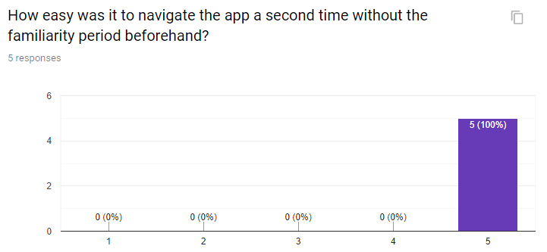

The results clearly show that the memorability law has been met as the agents clearly remembered how to use the app. It’s also worth noting that all of the participants made no errors when they were asked to perform the tasks again

# Changes and Conclusions

The testing clearly showed that the majority of Neilson’s laws were met without any issue, the only law that needed some improvement was the efficiency law. In order to combat this it was changed so that the user only needed to click on the card in order to display the extra earthquake information. This should make the app completely efficient as it was the only place the participants made any errors.